Operating Systems

ASSIGNMENT 1

CO1: Apply the concepts of operating system types, structures and system calls to demonstrate their functions in various computing environments – history of operating systems, mainframe, desktop, multiprocessor, distributed, clustered, real-time and handheld systems, OS structure, services, system calls, system design, CPU states, memory hierarchy and I/O systems.

Assignment Title: Evaluate and Justify the Operating-System Design of a Smart Hospital (Total Marks - 50) Nature of Assignment: Individual Duration: 1 Week Submission Date: 02-11-2026

Bloom’s Levels Assessed: K5 – Evaluate (every task in this assignment is at K5 level)

Mandatory Execution and GitHub Submission
- Every student must individually execute every task in this assignment, including all “Complete the Code” programs.
- Create a GitHub repository named CSA04-<RegisterNumber>-Assignment1 and share it with the course faculty (public, or private with the faculty added as a collaborator).
- Keep one folder for each task (for example: Task01, Task02 … or Q1, Q2 …), containing the C source files, shell scripts, configuration files (Dockerfile, YAML), command outputs and screenshots.
- Include a README.md with your name, register number, compiler and version (for example gcc 13), the Linux distribution and version used, the exact gcc command used to compile (for example gcc -std=c11 -Wall -Wextra -pthread), the steps to run each program, and a short note of the result of each task.
- Commit your work progressively – at least one commit for each task. The commit history will be checked; a single upload of all files on the last day will not be accepted.
- Submit the GitHub link below and on the cover page of your report. An assignment submitted without a working GitHub link will not be evaluated.

GitHub Repository Link: https://github.com/ramyab202008-hub/CSA04-1924260097-Assignment1

How to Answer the Additional Questions
Complete the Code: Copy the given code into your repository, replace every TODO with working code without changing the rest of the program, execute it and compare your output (or result) with the expected output.

Alternative Concept and Complexity Analysis: Describe how the solution would change if the alternative concept were used, with code or pseudocode, and analyse and compare the time complexity and space complexity of both solutions using Big-O notation, supported by your own measurements wherever possible.

Scenario — Operating Systems for a Smart Hospital
A 500-bed hospital is replacing its computer systems. It needs: bedside patient monitors that must raise an alarm within 10 milliseconds of an abnormal reading; nurses’ handheld tablets; doctors’ desktop workstations; a central database server for patient records that must never stop; an imaging server that processes MRI scans using many processors; and a link to two partner hospitals that share records.

The IT team has proposed using one general-purpose operating system everywhere. The clinical staff are concerned that alarms may be delayed, the database may stop during updates, and the tablets’ batteries will not last a shift.

The number of devices may grow:

1 ward (40 monitors, 10 tablets) → 1 hospital (500 monitors, 120 tablets, 80 workstations) → a group of 3 hospitals sharing records

You are required to evaluate the requirements of every part of the system, judge which type and structure of operating system suits each, examine how programs obtain OS services through system calls, and defend a complete operating-system plan for the hospital.

Design Challenge: The hospital is adding remote patient monitoring at home and a cloud-based records service.

Re-evaluate your original design and determine whether it should be retained, modified or redesigned.

TASK 1 – Evaluate the Requirements of Each Computing Environment 4 Marks
Bloom’s Level: K5 – Evaluate Evaluate what each part of the hospital needs from its operating system.

Discuss:
- Response-time, reliability, throughput, battery and security requirements of each device
- Which requirements conflict (for example: fast response and many users on one machine)
- Which requirements are critical to patient safety
- How the lessons from the history of operating systems (batch, time-sharing, personal, mobile) apply to each environment

You are expected to rank the requirements of each environment and justify the ranking.

Alternative Concept and Complexity Analysis
If the whole hospital used a single general-purpose operating system on every device, instead of a different type of OS for each environment, what would the solution be? Evaluate the worst-case alarm response time (unbounded scheduling delay versus a guaranteed deadline), the memory needed on each device, and the administration effort.

Evidence Expected
A ranked requirement table for every environment with a justification for each ranking.

Introduction:
A smart hospital needs different types of operating systems because each device has different requirements. Patient safety, fast response, reliability, security and performance are the main priorities.

1.1Ranked Requirements of Each Environment
Hospital environment | Priority ranking | Suitable OS
Bedside patient  monitors | 1. Response time 2. Reliability 3.  Security 4. Throughput | Real-Time Operating  System (RTOS)
Nurses' handheld  tablets | 1. Battery life 2. Reliability 3. Security  4. Response time | Mobile Operating System
Doctors' desktop  workstations | 1. Reliability 2. Security 3. Response time 4. Multitasking | Personal / Time-sharing OS
Central database  server | 1. Reliability 2. Security 3. Availability  4. Throughput | Server Operating System
MRI imaging server | 1. Processing speed 2. Throughput 3.  Reliability 4. Security | Multiprocessor / Parallel OS
Partner hospital network | 1. Security 2. Reliability 3. Availability  4. Data sharing | Distributed Operating System

1.2 Justification for Ranking

1. Bedside Patient Monitors
- Must detect abnormal patient readings quickly.
- Should raise alarms within 10 milliseconds.
- Must work continuously without failure.
- RTOS provides predictable response time.
- Patient safety is the highest priority.

2. Nurses' Handheld Tablets
- Should consume less battery power.
- Must provide quick access to patient records.
- Should support secure communication.
- Mobile OS is suitable for portable devices.

3. Doctors' Desktop Workstations
- Should support multiple applications.
- Must provide quick access to patient information.
- Should protect confidential medical records.
- Time-sharing OS supports multiple users and tasks.

4. Central Database Server
- Must run continuously without stopping.
- Should store and retrieve patient records safely.
- Must support many users at the same time.
- Server OS provides reliability and security.

5. MRI Imaging Server
- Must process large MRI images quickly.
- Should use multiple processors.
- Must handle large amounts of data.
- Parallel processing improves performance.

6. Partner Hospital Network
- Must share patient records securely.
- Should provide reliable communication.
- Must support data exchange between hospitals.
- Distributed OS concepts help coordinate multiple systems.
1.3 Application of Operating System Evolution
OS evolution | Application in hospital
Batch OS | Processing hospital reports and billing records in batches.
Multiprogramming OS | Running multiple hospital applications efficiently.
Time-sharing OS | Allowing doctors and nurses to access simultaneously. | systems
Personal OS | Used in doctors' desktop computers.
Mobile OS | Used in nurses' handheld tablets.
Real-Time OS | Used in bedside patient monitors.
Distributed OS | Used for sharing records between hospitals.

1.4 Alternative Concept and Complexity Analysis
If the entire hospital uses one general-purpose operating system instead of different operating systems, it creates some problems.
Disadvantages:
- Alarm response time may be delayed because of other running programs.
- It cannot guarantee a response within 10 milliseconds.
- More memory may be required to support different applications.
- Managing all devices using one OS becomes difficult.
- A system failure may affect many hospital services.
Comparison:
Factor | Different OS for each environment | Single General-Purpose OS
Alarm response | Guaranteed using suitable RTOS | No guaranteed deadline
Memory | Depends on device requirements | May require more resources
Reliability | High with suitable design | Depends on one common  platform
Administration | More complex | Easier to manage initially
Security | Can be customized | Common security management
Time Complexity: A general-purpose OS may have unpredictable scheduling delays under heavy load. An RTOS uses scheduling methods that provide predictable execution and bounded response times.
Space Complexity: Memory usage depends on the OS, applications and number of running processes. Lightweight RTOS needs fewer resources, while general-purpose OS may require more memory.

1.5 Conclusion
A single general-purpose OS is not suitable for every hospital device. Different operating systems should be selected according to device requirements. RTOS is essential for patient monitors because it provides predictable response time. Mobile OS, server OS and distributed OS are suitable for other hospital environments. This design improves patient safety, reliability, security and overall hospital performance.

TASK 2 – Judge the Type of Operating System for Each Environment 3 Marks
Bloom’s Level: K5 – Evaluate Compare the types of operating systems for the hospital.

Discuss:
- Mainframe, desktop, multiprocessor, distributed, clustered, real-time (hard and soft) and handheld systems
- Which type best fits the monitors, tablets, workstations, database server, imaging server and partner link
- Symmetric versus asymmetric multiprocessing for the imaging server
- A clustered system with fail-over for the database server

Alternative Concept and Complexity Analysis
If the database server used a single large multiprocessor machine instead of a cluster of smaller machines with fail-over, what would the solution be? Evaluate the availability (a single point of failure versus fail-over within seconds), the cost, and how throughput grows with the number of processors (time) and the memory available (space).

Evidence Expected
A justified choice of operating-system type for each environment, with the rejected alternatives and reasons.

Introduction:
A smart hospital requires different types of operating systems for different devices. Each OS is selected based on speed, reliability, security, availability and performance.

Suitable Operating System for Each Environment
Hospital environment | Suitable OS type | Reason
Bedside patient monitors | Hard Real-Time OS | Gives guaranteed response within 10 milliseconds.
Nurses' handheld tablets | Handheld / Mobile  OS | Supports portability and saves battery power.
Doctors' desktop workstations | Desktop OS | Supports multitasking and user-friendly applications.
Central database server | Clustered OS | Provides high availability and fail-over during failures.
MRI imaging server | Multiprocessor OS | Uses multiple processors to process large MRI images quickly.
Partner hospital link | Distributed OS | Allows secure sharing of patient records between hospitals.

Comparison of Different Operating System Types
OS type | Purpose | Hospital application
Mainframe OS | Handles large amounts of data and users | Large hospital data processing
Desktop OS | Supports personal computer applications | Doctors' workstations
Multiprocessor  OS | Uses multiple CPUs | MRI imaging server
Distributed OS | Connects multiple computers | Partner hospital network
Clustered OS | Connects computers for high availability | Database server
Hard Real-Time  OS | Guarantees response before a deadline | Patient monitors
Soft Real-Time OS | Provides fast response but occasional delays are acceptable | Non-critical medical image display
Handheld OS | Designed for portable devices | Nurses' tablets

Symmetric vs Asymmetric Multiprocessing
Symmetric Multiprocessing (SMP) | Asymmetric Multiprocessing (AMP)
All processors share tasks. | Each processor has a specific task.
Processors have equal responsibility. | One processor may control other processors.
Provides better load balancing. | Tasks are assigned separately.
Suitable for MRI imaging server. | Less flexible for general MRI workloads.
Selected: Symmetric Multiprocessing (SMP)
Reason: MRI processing requires multiple processors to work simultaneously. SMP improves processing speed and balances workloads.

Clustered System with Fail-over for Database Server
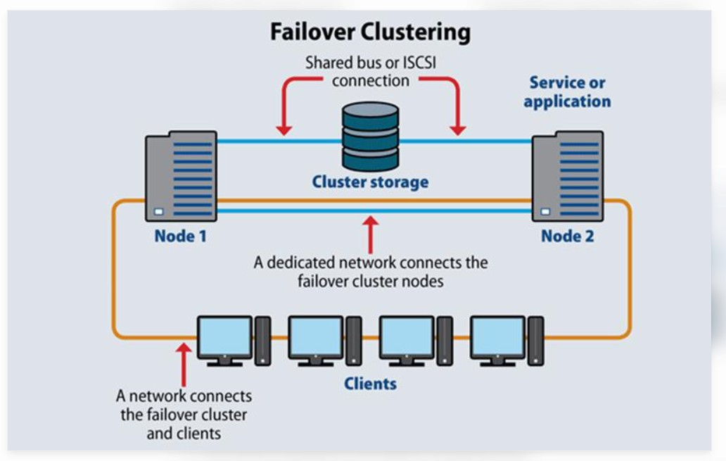
- A cluster contains two or more connected servers.
- One server handles the database operations.
- Another server acts as a backup.
- If the active server fails, the backup server takes over.
- This reduces downtime and protects hospital records.
Selected: Clustered System
Reason: The hospital database must operate continuously without stopping during updates or hardware failures.

Alternative Concept and Complexity Analysis
If the database uses one large multiprocessor computer instead of a cluster, it can process many tasks using multiple CPUs.
Comparison:
Factor | Clustered system | Single multiprocessor system
Availability | High availability with fail-over | Single point of failure
Failure | Backup server takes over | Entire server may stop
Cost | Higher setup cost | Lower initial setup cost
Performanc  e | Workload shared between servers | Workload shared between processors
Memory | Each server has its own memory | Processors share main memory
Time Complexity:
- Adding more processors can increase throughput.
- Multiple tasks can execute simultaneously.
- Performance does not increase perfectly because processors need to coordinate and share resources.
Space Complexity:
- More memory is required as the number of processes and data increases.
- A multiprocessor system shares main memory among processors.
- A cluster has separate memory in each server.

Conclusion
Different operating systems are required for different hospital environments. Hard RTOS is best for patient monitors, mobile OS for tablets, desktop OS for workstations, clustered OS for database servers, multiprocessor OS for MRI imaging and distributed OS for partner hospitals. A clustered database system with fail-over is the best choice because it provides high availability, reliability and continuous hospital services.

TASK 3 – Evaluate Operating-System Structures 4 Marks
Bloom’s Level: K5 – Evaluate Evaluate the possible structures of the operating system.

Discuss:
- Simple (monolithic), layered, microkernel, modular (loadable kernel modules) and hybrid structures
- The effect of each structure on reliability, performance and ease of updating
- Which structure suits the patient monitors and which suits the database server
- How Linux, Windows, Android and a real-time OS such as FreeRTOS or QNX are structured

Alternative Concept and Complexity Analysis
If the bedside monitors used a monolithic kernel instead of a microkernel, what would the solution be? Evaluate the time cost of a service request (one system call versus message passing between servers), the memory taken by the kernel, and the effect of a faulty driver on the whole system.

Evidence Expected
A comparison of structures against the hospital’s requirements, with a defended choice for two environments.
Introduction:
Operating-system structure describes how the different parts of an OS are organized and communicate with each other. A smart hospital needs a suitable structure to provide reliability, performance, security and easy updates.

Comparison of Operating-System Structures
OS structure | Description | Advantages | Disadvantages
Monolithic | All OS services work inside one large kernel. | High performance | One error may affect the whole system.
Layered | OS is divided into different layers. | Easy to understand and maintain | Communication between layers may be slower.
Microkernel | Only essential services run in the kernel. Other services run separately. | High reliability and security | Message passing may reduce performance.
Modular | Kernel supports additional modules that can be loaded when needed. | Easy to update and flexible | Faulty modules may affect the kernel.
Hybrid | Combines features of monolithic and microkernel structures. | Good performance and  flexibility | Complex design.

Effect of Each Structure
Structure | Reliability | Performance | Easy updating
Monolithic | Low | High | Difficult
Layered | Good | Moderate | Easy
Microkernel | Very high | Moderate | Easy
Modular | Good | High | Easy
Hybrid | High | High | Moderate

Suitable Structure for Hospital Environments
- Bedside Patient Monitors – Microkernel
  - Provides high reliability.
  - Separates services from the main kernel.
  - Faults in one service are less likely to affect the entire system.
  - Suitable for critical patient monitoring.
- Central Database Server – Modular Structure
  - Supports additional kernel modules.
  - Provides high performance.
  - Allows easy updates and maintenance.
  - Suitable for handling large amounts of patient records.

Structure of Popular Operating Systems
Operating system | Structure | Explanation
Linux | Monolithic with modules | Supports loadable kernel modules.
Windows | Hybrid | Combines monolithic and microkernel concepts.
Android | Layered architecture with Linux kernel | Uses Linux kernel and multiple software layers.
FreeRTOS | Small monolithic kernel | Provides lightweight real-time task scheduling.
QNX | Microkernel | Runs many services outside the kernel.

Alternative Concept and Complexity Analysis
If bedside patient monitors use a monolithic kernel instead of a microkernel, all OS services and drivers work inside the same kernel.
Comparison:
Factor | Monolithic Kernel | Microkernel
Service request | Direct system call | Message passing between servers
Speed | Faster | Comparatively slower
Kernel memory | Larger | Smaller
Reliability | Lower fault isolation | Better fault isolation
Driver failure | May affect the entire system | Usually affects only the related service
Security | Larger trusted kernel | Smaller trusted kernel
Time Complexity:
- Monolithic kernel: A service request uses a direct system call, so communication overhead is low.
- Microkernel: A service request may require message passing between separate services, adding communication overhead.
Space Complexity:
- Monolithic kernel requires more kernel memory because many services run inside it.
- Microkernel requires less kernel memory because most services run outside the kernel.
Effect of Driver Failure:
In a monolithic kernel, a faulty driver can crash the entire operating system. In a microkernel, driver failures can be isolated, reducing the risk of affecting other services.

Conclusion
Microkernel structure is the best choice for bedside patient monitors because it provides better reliability and fault isolation. Modular structure is suitable for the database server because it provides high performance and easy updates. Selecting the correct OS structure improves patient safety, system reliability and hospital performance.

TASK 4 – Evaluate the Services an Operating System Must Provide 4 Marks

Bloom’s Level: K5 – Evaluate Evaluate the services each environment needs.

Discuss:
- User interface, program execution, I/O operations, file systems, communication, error detection, resource allocation, accounting, protection and security
- Which services can be removed from the bedside monitor to make it smaller and faster
- Which services are essential for the database server
- How the OS protects one patient’s records from another user’s programs

Alternative Concept and Complexity Analysis
If the tablets used a full desktop operating system with every service enabled instead of a reduced handheld OS, what would the solution be? Evaluate the memory and storage used by the extra services (space), the start-up time and the battery life (time).

Evidence Expected
A service table for each environment with justified inclusions and exclusions.
Introduction:
An operating system provides different services to users and applications. In a smart hospital, these services help manage patient records, monitor devices, communicate between systems and protect confidential information.

Operating System Services and Their Uses
OS service | Purpose | Hospital application
User Interface | Allows users to interact with the system. | Doctors and nurses access applications.
Program Execution | Runs application programs. | Runs patient monitoring software.
I/O Operations | Controls input and output devices. | Reads patient monitor sensors.
File System | Stores and manages files. | Stores patient reports and medical images.
Communication | Allows systems to exchange data. | Shares records between hospitals.
Error Detection | Detects hardware and software errors. | Detects sensor and system failures.
Resource Allocation | Distributes CPU and memory. | Manages multiple hospital applications.
Accounting | Records resource usage. | Tracks system usage and activities.
Protection | Prevents unauthorized access. | Protects individual patient records.
Security | Protects data from threats. | Uses passwords and encryption.

Services Required for Each Hospital Environment
Hospital environment |  | Essential services
Bedside monitors | patient | Program execution, I/O operations, error detection, resource allocation and security.
Nurses' tablets | handheld | User interface, program execution, communication, file system and security.
Doctors' workstations | desktop | User interface, program execution, I/O operations, file system and protection.
Central database server |  | File system, communication, protection, security, error detection and resource allocation.
MRI imaging server |  | Program execution, I/O operations, file system, communication and resource allocation.
Partner hospital  network |  | Communication, protection, security and error detection.

Services That Can Be Removed from Bedside Monitors
To make bedside monitors smaller and faster, unnecessary services can be removed.
Services that can be reduced or removed:
- Complex graphical user interface.
- Unnecessary background applications.
- General-purpose accounting services.
- Unnecessary file management features.
- Unused network communication services.
Services that must remain:
- Sensor input/output operations.
- Real-time program execution.
- Error detection.
- Resource allocation.
- Essential security and protection.
Reason: Removing unnecessary services reduces memory usage and improves response speed. However, patient monitoring and alarm services must always remain active.

Essential Services for the Database Server
The central database server requires all important OS services.
- File system – Stores patient records.
- Communication – Connects doctors and nurses.
- Protection – Prevents unauthorized access.
- Security – Protects confidential information.
- Error detection – Identifies system problems.
- Resource allocation – Manages CPU and memory.
- Accounting – Records user activities.
- Program execution – Runs database applications.
Reason: The database server must provide continuous access, secure storage and reliable patient information.

How the OS Protects Patient Records
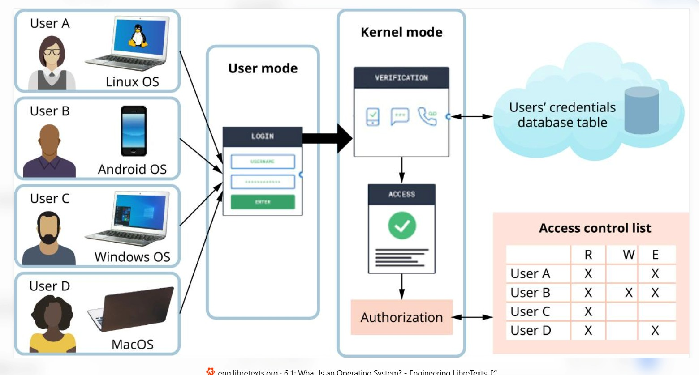
The OS protects patient records using:
- Authentication: Checks the user's username and password.
- Authorization: Gives access only to permitted records.
- Access Control: Prevents one patient's data from being accessed by unauthorized programs.
- Encryption: Converts sensitive information into protected data.
- Process Isolation: Keeps different programs separate.
- Audit Logs: Records who accessed or modified patient records.
Example: A doctor can access the records of assigned patients, while another user's program cannot access those records without permission.

Alternative Concept and Complexity Analysis
If nurses' tablets use a full desktop OS instead of a reduced handheld OS, more system services and background applications will run.
Comparison
Factor | Handheld OS |  | Full Desktop OS
Memory usage | Low |  | High
Storage usage | Less |  | More
Start-up time | Faster |  | Slower
Battery life | Longer |  | Shorter
Background services | Limited |  | More
Performance | Suitable tablets | for | Requires resources | more

Space Complexity
- Handheld OS uses less memory and storage.
- Desktop OS requires additional memory and storage for background services, drivers and applications.
- Therefore, desktop OS consumes more resources.

Time Complexity
- Handheld OS starts faster because fewer services need to load.
- Desktop OS takes more time to start because many services run during booting.
- More background processes consume battery power and reduce battery life.
Selected: Handheld OS
Reason: It is lightweight, consumes less power and is suitable for nurses' portable tablets.

Conclusion
Different hospital environments require different OS services. Bedside monitors need essential real-time services, while database servers require complete file management, communication and security services. Handheld OS is best for nurses' tablets because it saves memory, storage and battery power. Proper OS services improve hospital efficiency, patient safety and data protection.

TASK 5 – Examine System Calls 4 Marks
Bloom’s Level: K5 – Evaluate Examine how a program obtains OS services.

Discuss:
- The categories of system calls (process control, file management, device management, information maintenance, communication, protection)
- What happens step by step when a program calls read(): library call, trap, mode switch, kernel work, return
- How parameters are passed to the kernel (registers, a block in memory, the stack)
- How strace shows the system calls made by a program

Alternative Concept and Complexity Analysis
If programs called the C library functions fopen, fread and fwrite instead of the open, read and write system calls directly, what would the solution be? Evaluate the number of system calls for a file of n bytes (about n / 4096 with library buffering versus n / b for a buffer of b bytes) and the extra buffer space used by the library.

Evidence Expected
A step-by-step explanation of a system call with strace evidence from a real program.

Introduction:
System calls act as a bridge between user programs and the operating system kernel. They allow programs to request OS services such as file handling, process creation, device access and communication.

Categories of System Calls
Category | Purpose | Examples
Process Control | Creates and controls processes. | fork(), exec(), exit()
File Management | Creates, reads and writes files. | open(), read(), write(),  close()
Device Management | Controls input and output devices. | ioctl(), read(), write()
Information Maintenance | Gets system information. | getpid(), time()
Communication | Allows processes to exchange data. | pipe(), socket(), send(), recv()
Protection | Controls access permissions. | chmod(), chown(), access()

Steps Involved When a Program Calls read()
When a program calls read(), the following steps take place:
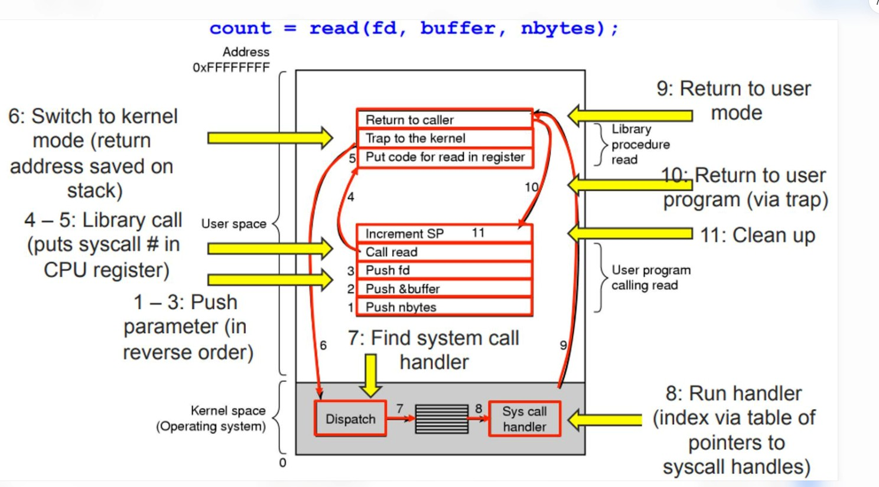
- Library Call: The program calls the read() library function.
- Trap: The library wrapper requests a system call using a trap instruction.
- Mode Switch: CPU changes from user mode to kernel mode.
- Kernel Work: Kernel checks the file descriptor and reads the requested data.
- Return: Kernel returns the result to the program.
- Mode Switch Back: CPU returns to user mode and continues execution.

Methods of Passing Parameters to the Kernel
Parameters are passed to the kernel in three ways:
- Registers: Parameters are stored directly in CPU registers.
- Memory Block: Parameters are stored in a memory block, and its address is passed to the kernel.
- Stack: Parameters are pushed onto the stack, and the kernel retrieves them.

4. How strace Shows System Calls
strace is a Linux command-line tool used to observe system calls made by a program. Example C program:
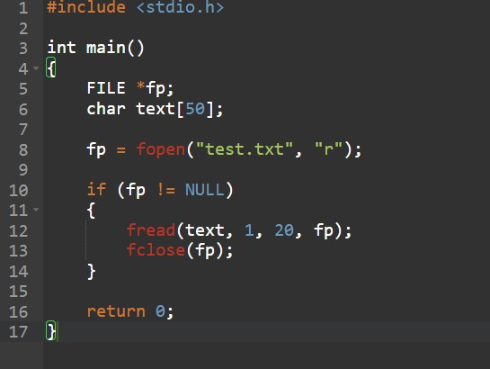

Explanation:
- openat() – Opens the file.
- read() – Reads data from the file.
- close() – Closes the file.
- exit_group() – Terminates the program.

Alternative Concept and Complexity Analysis
If programs use C library functions such as fopen(), fread() and fwrite() instead of directly calling open(), read() and write(), the C library handles file buffering.

Comparison
Factor | Direct System Calls | C Library Functions
Opening | open() | fopen()
Reading | read() | fread()
Writing | write() | fwrite()
Buffering | Managed by program | Managed by library
Performanc  e | More system calls for small transfers | Fewer system calls with buffering

Time Complexity
For a file containing n bytes:
- With library buffering of 4096 bytes, approximately read system calls are
needed. 𝑛/4096
- With direct system calls using a buffer of b bytes, approximately read system calls
are needed. 𝑛/𝑏
Fewer system calls reduce kernel-user mode switching overhead.

Space Complexity
- Direct system calls do not automatically allocate a C library file buffer.
- C library functions allocate extra buffer memory (for example, 4096 bytes).
- Therefore, library buffering uses additional memory but can improve performance.
Example:
For a 16,384-byte file:
- Library buffering: 16,384 / 4096 = 4 system calls.
- Direct reading with 512-byte buffers: 16,384 / 512 = 32 system calls.

Conclusion
System calls allow user programs to communicate with the operating system kernel. Functions such as read(), write() and open() provide file services. The strace tool helps identify system calls. C library buffering reduces the number of system calls and improves file-handling performance by using additional memory.

TASK 6 – Evaluate the Cost of System Calls 4 Marks
Bloom’s Level: K5 – Evaluate Evaluate how the number of system calls affects performance.

Discuss:
- Why each system call costs much more than an ordinary function call
- How the buffer size changes the number of read() and write() calls when the database copies a file
- How library buffering (fread, fwrite) reduces the number of system calls
- The best buffer size for the hospital’s backup program, using your measurements

Complete the Code
Complete TODO 1 below using the read() and write() system calls, and execute the program on Linux.

- How library buffering (fread, fwrite) reduces the number of system calls
- The best buffer size for the hospital’s backup program, using your measurements

Complete the Code
Complete TODO 1 below using the read() and write() system calls, and execute the program on Linux.

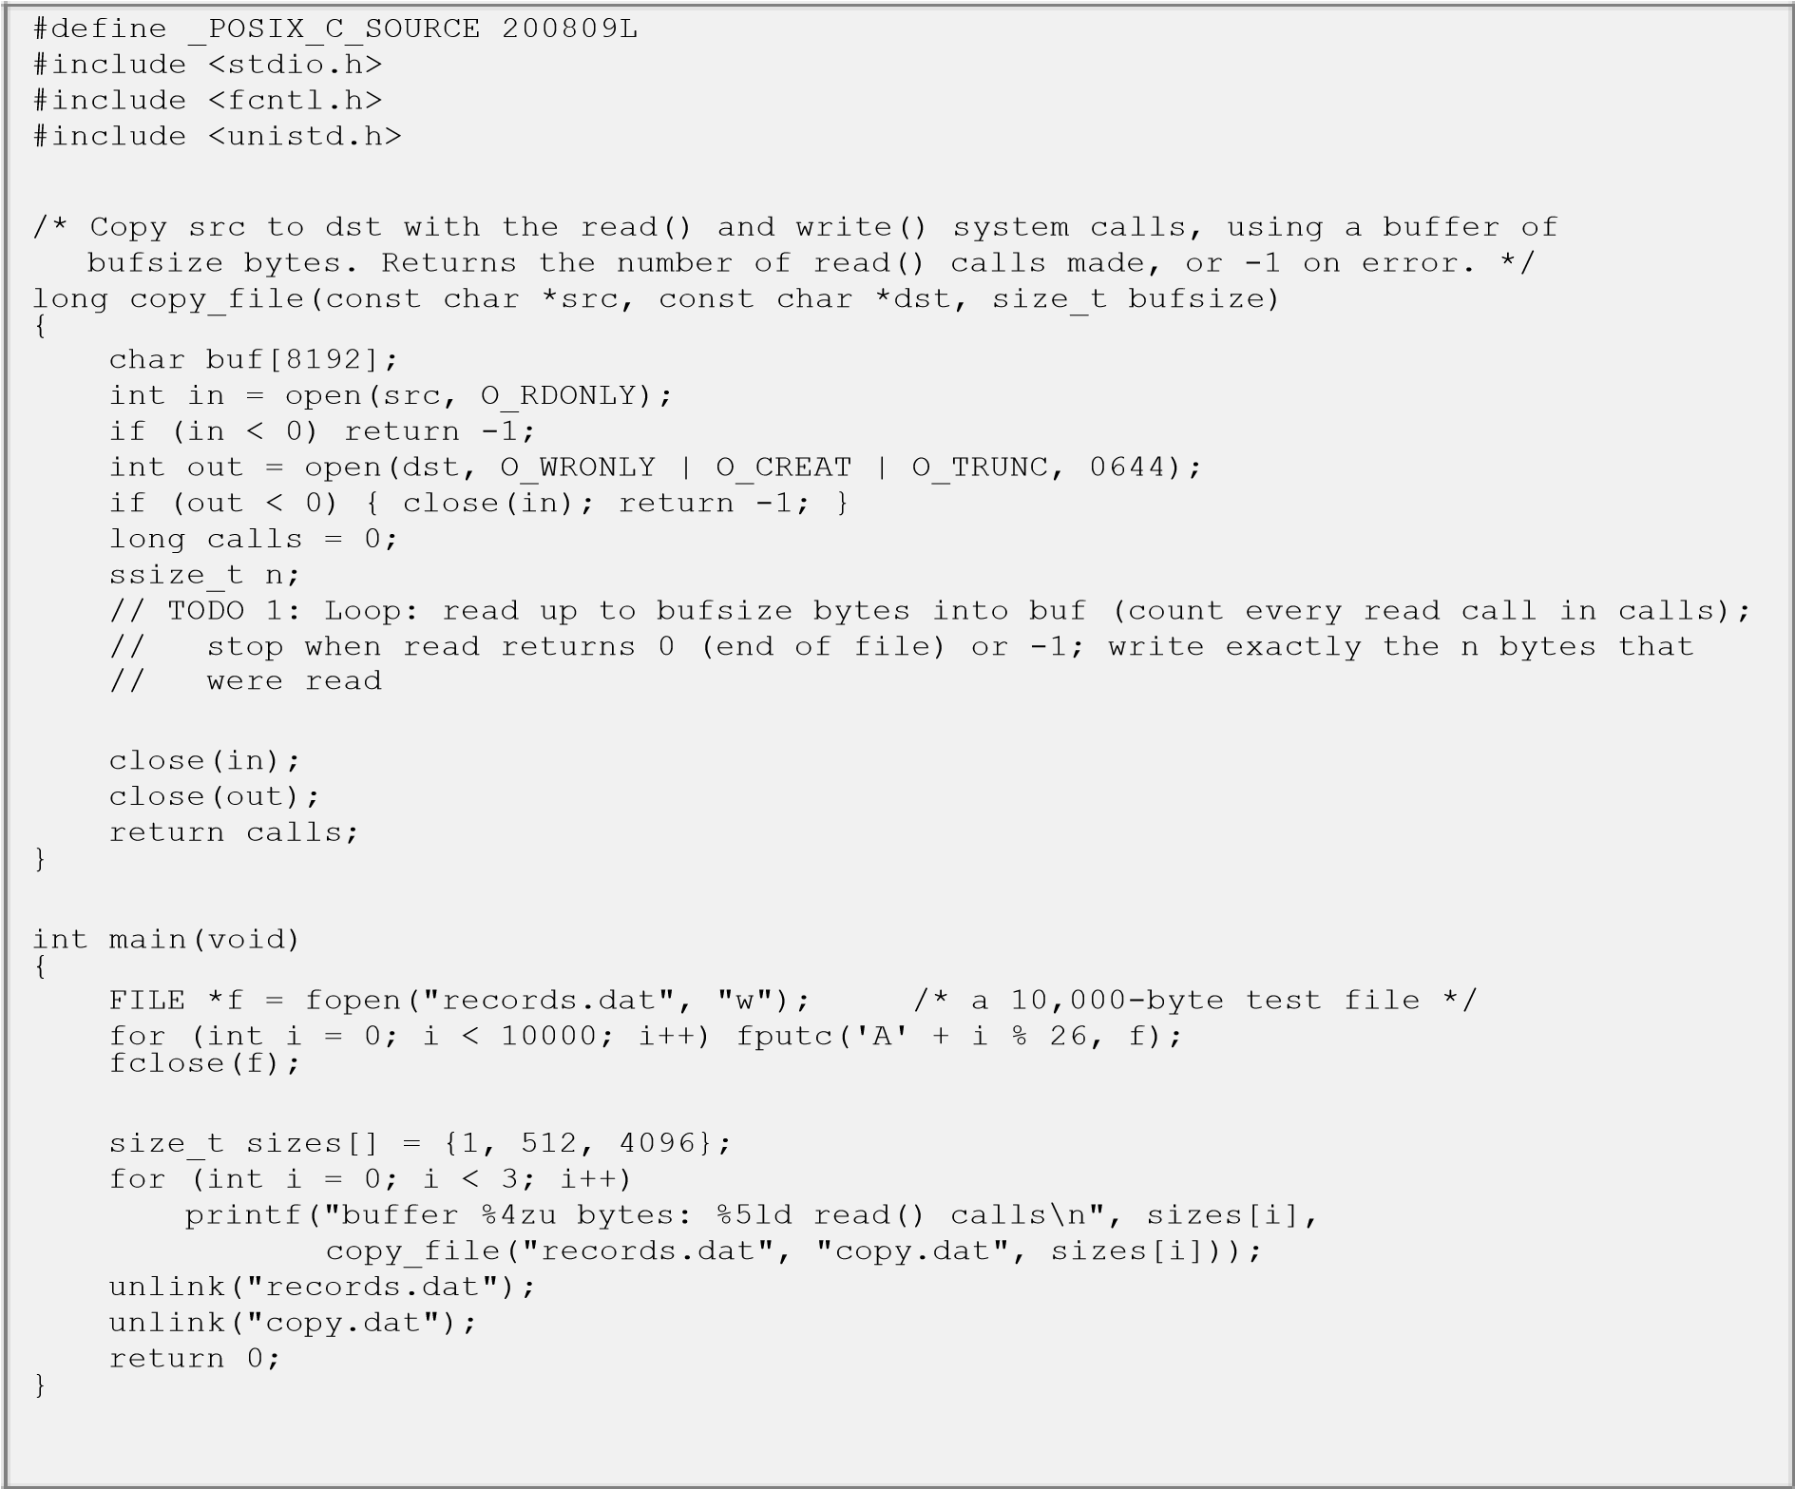
Expected output:
buffer

1

bytes:

10001

read()

calls

buffer

512

bytes:

21

read()

calls

buffer

4096

bytes:

4

read()

calls

Run the program under strace -c and compare the number of read() calls reported with the program’s output.

Alternative Concept and Complexity Analysis
If the backup program used memory-mapped files (mmap) instead of read() and write() with a buffer, what would the solution be? Evaluate the number of system calls (a few versus about n / b), the copying between kernel and user space, and the memory used for very large files.

Evidence Expected
Measured system-call counts and times for different buffer sizes, with a justified recommendation.

Introduction:
System calls allow user programs to communicate with the operating system kernel. Each system call takes extra time because the CPU switches from user mode to kernel mode. Using larger buffers reduces the number of system calls and improves performance.
Why Does Each System Call Cost More Than an Ordinary Function Call?
- An ordinary function call executes within the same program.
- A system call switches the CPU from user mode to kernel mode.
- The OS checks permissions and validates parameters.
- The kernel performs the requested operation. ● The result is returned to the user program.
Therefore: System calls require more processing time than ordinary function calls.

Effect of Buffer Size on read() and write()
Buffer size determines how many bytes are transferred in one system call.
Buffer size | Number of read() calls | Performance
1 byte | 10001 | Very slow
512 bytes | 21 | Better
4096 bytes | 4 | Faster
Explanation:
- Small buffer → More system calls.
- Large buffer → Fewer system calls.
- Fewer system calls → Less switching overhead.
- Therefore, larger buffers improve file-copying performance.

How Library Buffering Reduces System Calls
C library functions use internal buffers to reduce system calls.
Function | Purpose
fopen() | Opens a file
fread() | Reads data using buffering
fwrite() | Writes data using buffering
fclose() | Closes the file
For example, when copying a 10,000-byte file using a 4096-byte buffer= 3 + 1 = 4 The additional call is for detecting the end of the file.

Complete the Code (TODO 1)
The following code completes the file-copying program using read() and write() system calls
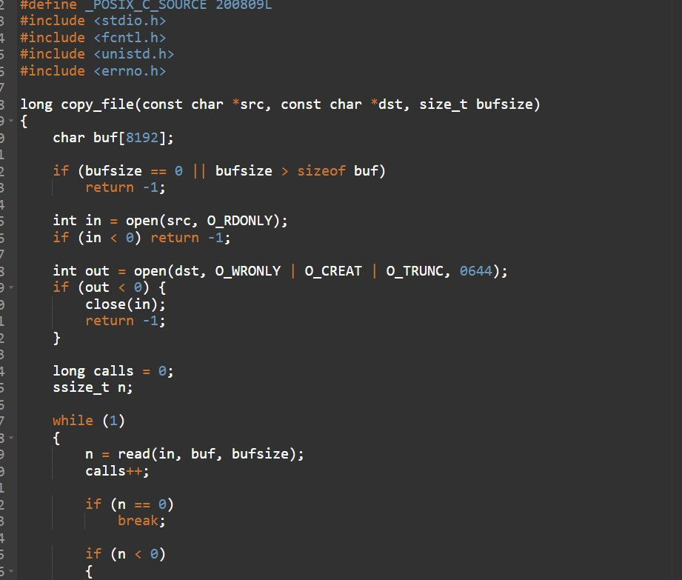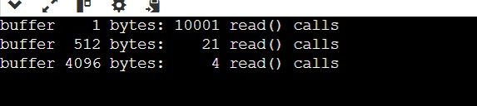

Comparison
Factor | read() and write() | mmap()
System calls | About n/b calls | Only a few mapping calls
Data transfer | Uses a user-space buffer | Accesses mapped file pages
Memory | Requires a buffer | Uses virtual memory mapping
Performance | Depends on buffer size | Can be faster for some workloads
Large files | Copies in chunks | Maps file pages on demand

Time Complexity
- read() and write() require approximately system calls. ● mmap() requires only a few setup system calls.𝑛 /𝑏
- Memory mapping reduces repeated system-call overhead.
- Page faults may occur when accessing unmapped file pages.

Space Complexity
- read() and write() use a fixed-size buffer.
- mmap() maps the file into virtual memory.
- Physical memory pages are loaded when required.
- Very large files can use large virtual address ranges.
Disadvantage: Memory mapping requires careful management of mapped regions and file sizes.

9. Final Conclusion
System-call overhead affects the performance of file-copying operations. Larger buffers reduce the number of read() and write() calls. Library buffering also improves performance by reducing system calls. In this experiment, a 4096-byte buffer is the best choice because it requires only 4 read() calls and uses just 4 KB of buffer memory. Memory mapping is another alternative for efficient file access, especially for suitable large-file workloads.

TASK 7 – Evaluate Process Control System Calls 4 Marks
Bloom’s Level: K5 – Evaluate Evaluate how a command shell on the database server starts and manages programs.

Discuss:
- What fork(), exec(), wait() and exit() each do
- How a shell runs a command, and how it obtains the command’s exit status
- What a zombie and an orphan process are, and how the OS deals with them
- Why fork() followed by exec() is used instead of a single “create process” call

Complete the Code
Complete TODO 1 below using fork(), execlp() and waitpid(), and execute the program on Linux.
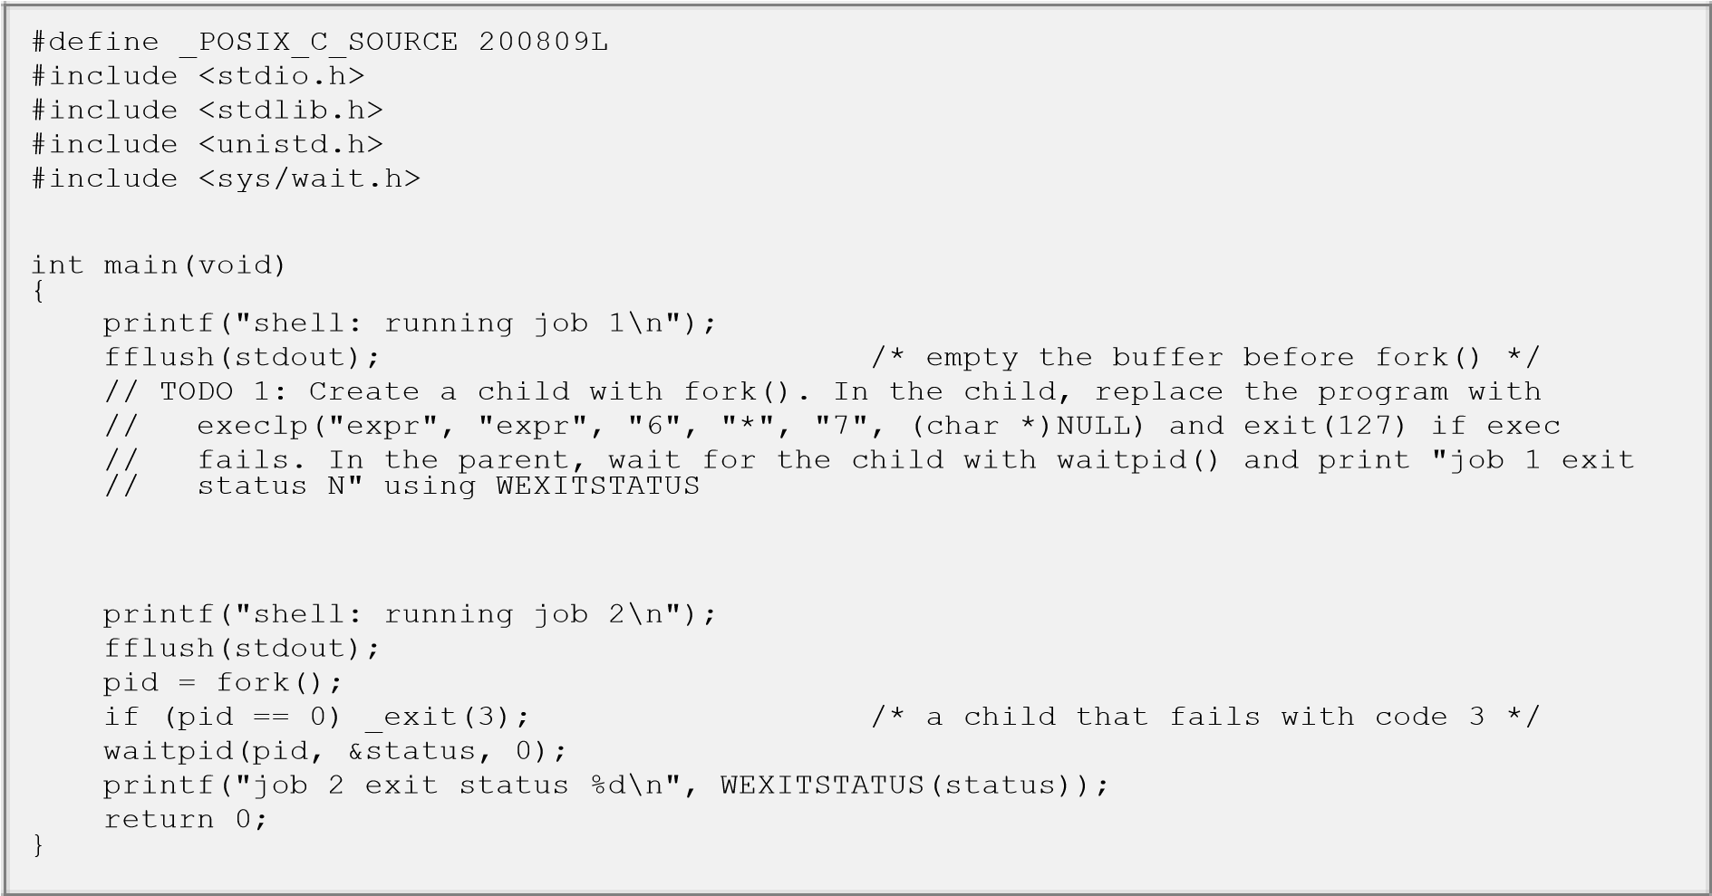

Expected output:
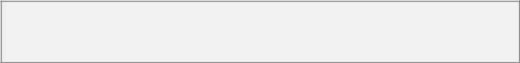
shell:

running

job

1

42

job

1

exit

status

0

shell:

running

job

2

job

2

exit

status

3

Explain why stdout is flushed before each fork(). Then remove the second fflush(stdout), change _exit(3) to exit(3), redirect the output to a file and explain why “shell: running job 2” now appears twice.

Alternative Concept and Complexity Analysis
If commands were run with posix_spawn() or with threads instead of fork() followed by exec(), what would the solution be? Evaluate the time to start 1,000 commands, the memory copied or shared (copy-on-write), and the isolation between commands.

Evidence Expected
A working program that runs commands like a shell, with process diagrams and a reasoned evaluation.

Introduction:
Process control system calls help the operating system create, execute, manage and terminate processes. In a hospital database server, the command shell uses these calls to start and manage different programs.

Functions of Process Control System Calls
System call | Purpose
fork() | Creates a new child process.
exec() | Replaces the current process with a new program.
wait() | Makes the parent wait until the child process finishes.
exit() | Terminates a process and returns an exit status.

2. How a Shell Runs a Command
When a user enters a command, the shell performs these steps:
- The shell receives the command.
- fork() creates a child process.
- The child uses exec() to execute the requested program.
- The parent uses waitpid() to wait for the child.
- The child completes execution and calls exit().
- The parent collects the child's exit status.
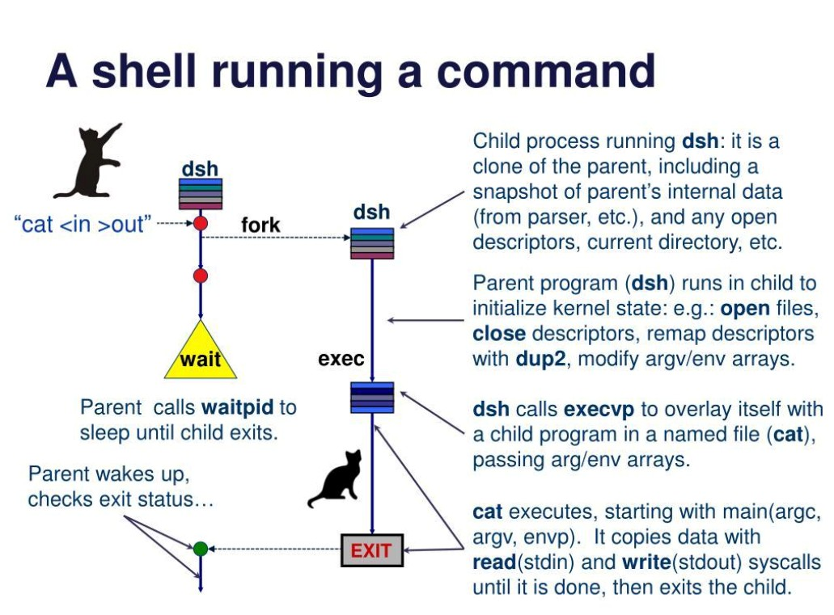

Why fork() Followed by exec() Is Used
- fork() creates a child process.
- exec() loads a new program into that child.
- The parent can continue running independently.
- It allows the shell to manage multiple commands.
- It provides flexibility for input/output redirection and pipelines.
Reason: Using two calls separates process creation from program execution and gives the shell more control.
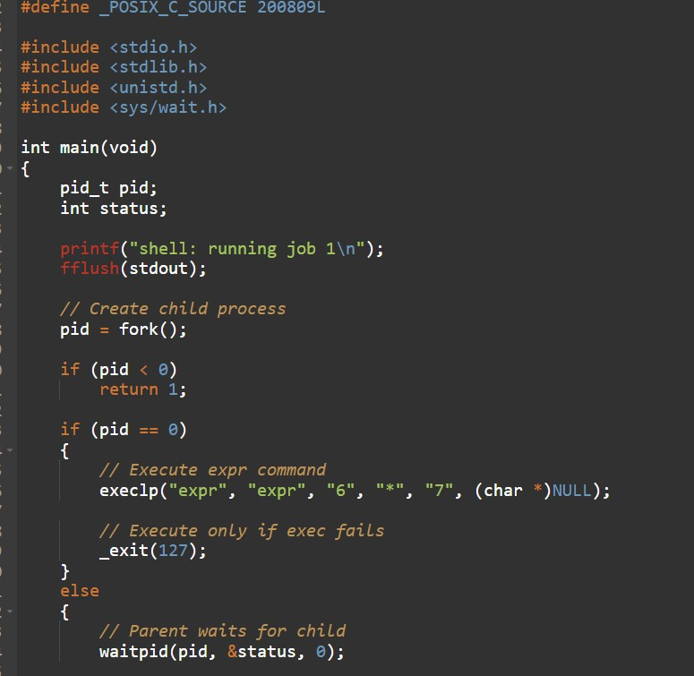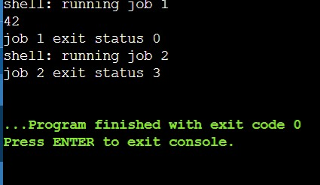

Alternative Concept and Complexity Analysis
If the shell uses posix_spawn() or threads instead of fork() followed by exec(), process creation can be handled differently.

Comparison
Factor | fork() + exec() | posix_spawn() | Threads
Creatio n | Creates child, then executes program | Creates and executes program | Creates threads
Speed | Moderate | Often faster | Usually faster
Memor  y | Uses copy-on-write | Avoids a separate fork step | Shares process memory
Isolatio n | High | High | Low
Security | Separate process | Separate process | Shared address space

A. Time Complexity
- Starting 1,000 commands requires 1,000 process creations.
- fork() + exec() involves two operations per command. ● posix_spawn() can reduce process-startup overhead.
- Threads have lower creation overhead but are not equivalent to independent processes.
Actual execution time depends on CPU, memory and operating-system scheduling.

B. Space Complexity
- fork() uses copy-on-write, so memory pages are shared until modified. ● posix_spawn() avoids the separate fork stage.
- Threads share the same process memory.
- Each thread still needs its own stack and thread-management resources.

C. Isolation
- Separate processes protect commands from directly modifying one another's memory.
- Threads share memory, so one thread can affect another.
- Therefore, separate processes are safer for running independent hospital database commands.

9. Conclusion
Process control system calls help the shell execute and manage programs. fork() creates a child, exec() runs a new program, waitpid() collects its status and exit() terminates it. For hospital database servers, separate processes provide better isolation and reliability. posix_spawn() is another efficient alternative for starting independent commands.

TASK 8 – Evaluate CPU States and Protection 3 Marks
Bloom’s Level: K5 – Evaluate Evaluate how the hardware protects the hospital system.

Discuss:
- User mode and kernel mode, privileged instructions and the mode bit
- Interrupts, traps and the timer interrupt
- What would happen to the monitors if any program could disable interrupts
- How the hardware stops one program from reading another program’s memory

Alternative Concept and Complexity Analysis
If the monitors used polling (checking the sensor in a loop) instead of interrupts, what would the solution be? Evaluate the worst-case delay before an abnormal reading is noticed (the polling interval versus the interrupt latency) and the CPU time and power wasted by polling.

Evidence Expected
A reasoned explanation of CPU modes, interrupts and protection, applied to the monitors.

Introduction:
Hardware protection helps the operating system protect the hospital system from unauthorized access and program failures. It ensures that patient monitors work safely and continuously.
User Mode and Kernel Mode The CPU operates in two modes:
User Mode | Kernel Mode
Runs user applications. | Runs operating system functions.
Cannot execute privileged instructions. | Can execute privileged instructions.
Has limited access to hardware. | Has full access to hardware resources.
Provides protection. | Manages system resources.
Mode Bit:
- A hardware bit indicates the current CPU mode.
- User mode has limited privileges.
- Kernel mode has full privileges.
- System calls switch the CPU from user mode to kernel mode.
Privileged Instructions:
These are special instructions that only the kernel can execute.
Examples:
- Disabling interrupts.
- Controlling hardware devices.
- Changing memory management settings.

2. Interrupts, Traps and Timer Interrupts
Type | Meaning | Hospital example
Interrupt | Signal from hardware that needs CPU attention. | Patient sensor sends an alert.
Trap | Software-generated signal to request OS service or report an exception. | Program calls a system call.
Timer  Interrupt | Periodic signal generated by a timer. | Allows the OS to schedule other tasks.
Importance:
- Interrupts help the CPU respond to urgent events.
- Traps allow programs to request OS services.
- Timer interrupts prevent one program from occupying the CPU forever.
3. What Happens If Any Program Can Disable Interrupts?
If any program can disable interrupts:
- Patient monitor alerts may be delayed.
- CPU may not respond to abnormal readings.
- Other important hospital tasks may stop.
- System performance and reliability decrease.
- Patient safety may be affected.
Conclusion: Only the kernel should be allowed to disable interrupts because patient monitoring requires continuous and reliable operation.

4. How Hardware Protects One Program's Memory from Another
The hardware uses a Memory Management Unit (MMU) to protect memory.
- Each program gets its own virtual address space.
- The MMU translates virtual addresses into physical addresses.
- Access permissions control reading and writing.
- Unauthorized memory access generates a protection fault. ● The OS handles the fault and prevents illegal access.
Example: A nurse's application cannot directly read another patient's private application memory.

5. Alternative Concept and Complexity Analysis – Polling vs Interrupts
If patient monitors use polling instead of interrupts, the CPU continuously checks sensor readings at regular intervals.
Comparison
Factor | Polling | Interrupts
Working | CPU repeatedly checks sensors. | Sensor sends a signal when needed.
Response time | Depends on polling interval. | Usually faster.
CPU usage | Higher | Lower when idle
Power consumption | More | Less
Efficiency | Lower | Higher

A. Worst-Case Response Delay
- Polling checks sensors at fixed intervals.
- If the polling interval is 100 milliseconds, an abnormal reading may wait nearly 100 milliseconds before detection.
- Interrupts notify the CPU immediately when an event occurs, subject to interrupt latency and scheduling delays.

B. CPU Time and Power
Polling:
- CPU repeatedly checks sensors.
- Wastes processing time when there are no changes. ● Consumes more battery power.
Interrupts:
- CPU can perform other tasks while waiting.
- CPU responds when an event occurs.
- Reduces unnecessary processing and power consumption.
Selected: Interrupt-Based System
Reason: Interrupts are more suitable for bedside patient monitors because they provide faster event notification and reduce unnecessary CPU usage.
6. Conclusion
Hardware protection is essential for smart hospitals. User mode and kernel mode protect important OS operations. Interrupts help patient monitors respond to abnormal readings quickly. The MMU protects patient data from unauthorized memory access. Therefore, interrupt-based monitoring with hardware memory protection provides better reliability, security and patient safety.

TASK 9 – Evaluate the Memory Hierarchy and I/O Systems 4 Marks
Bloom’s Level: K5 – Evaluate Evaluate how data moves between storage levels and devices.

Discuss:
- The levels of the memory hierarchy (registers, cache, main memory, SSD, hard disk, network storage) with typical access times and sizes
- Where MRI images, patient records and monitor readings should be kept
- Programmed I/O, interrupt-driven I/O and DMA, and which suits the MRI scanner
- The effect of caching on the speed of record look-up

Alternative Concept and Complexity Analysis
If the MRI scanner transferred images with interrupt-driven I/O (one interrupt per word) instead of DMA, what would the solution be? Evaluate the number of interrupts and the CPU time for a 500 MB image, and the memory buffers needed in each method.

Evidence Expected
A justified data-placement plan and I/O method for each device, using typical access times.

Introduction:
Memory hierarchy organizes data storage based on speed, capacity and cost. In a smart hospital, it helps store MRI images, patient records and monitor readings efficiently. I/O systems help transfer data between devices and memory.

1. Levels of Memory Hierarchy
Memory hierarchy is arranged from fastest to slowest.
Memory level | Typical access time | Typical capacity
Registers | Less than 1 ns | Bytes
Cache | 1–10 ns | KB to MB
Main Memory (RAM) | 50–100 ns | GB
SSD | 50–200 µs | Hundreds of GB to TB
Hard Disk (HDD) | 5–15 ms | TB
Network Storage | 1–100 ms or more | TB to PB
Explanation:
- Registers store data currently used by the CPU.
- Cache stores frequently accessed data.
- RAM stores currently running programs and data.
- SSD provides fast permanent storage.
- HDD provides large-capacity storage.
- Network storage allows multiple hospitals to share data.

2. Suitable Storage for Hospital Data
Hospital data | Suitable storage | Reason
MRI Images | SSD and Network Storage | Fast image processing and long-term storage.
Patient Records | SSD and Database Server | Fast searching and secure access.
Monitor Readings | RAM and SSD | Quick processing and permanent recording.
Reason: Frequently accessed data should be stored in faster memory, while large medical files and old records can be stored in high-capacity storage.

3. Types of I/O Systems
There are three main types of I/O methods.
I/O method | Working | Advantages | Disadvantages
Programmed I/O | CPU continuously checks the device. | Simple implementation | Wastes CPU time.
Interrupt-driven I/O | Device interrupts CPU when it needs attention. | Reduces CPU waiting time | Frequent interrupts create overhead.
DMA (Direct  Memory Access) | Transfers data directly between device and memory. | Fast transfer with less CPU involvement | Requires DMA hardware support.
Selected: DMA for MRI Scanner
Reasons:
- MRI images contain large amounts of data.
- DMA transfers data directly into main memory.
- CPU can perform other tasks during transfer.
- Reduces the number of interrupts.
- Improves overall system performance.

4. Effect of Caching on Patient Record Lookup
Caching stores frequently accessed patient records in faster memory.
Working:
- Doctor searches for a patient record.
- OS checks the cache first.
- If the record is available, it is returned quickly (cache hit).
- Otherwise, it is retrieved from the database or storage (cache miss).
- Frequently accessed records may be cached for future use.
Advantages:
- Faster patient record searching.
- Reduces disk access.
- Improves database performance.
- Reduces response time.

5. Alternative Concept and Complexity Analysis – Interrupt-Driven I/O vs DMA
If the MRI scanner uses interrupt-driven I/O instead of DMA, the CPU must handle every data-transfer interrupt.

A. Number of Interrupts
Given:
- MRI image size = 500 MB
- One word = 4 bytes
Convert MB into bytes:
500 × 1024 × 1024 = 524288000𝑏𝑦𝑡𝑒𝑠
Number of words:
5242880004 = 131072000
131,072,000 interrupts
Therefore, one interrupt per word requires approximately 131 million interrupts.

B. CPU Time
Assume each interrupt takes 1 microsecond to handle.

𝐶𝑃𝑈𝑡𝑖𝑚𝑒 = 131072000 × 1µ𝑠

= 131. 072𝑠𝑒𝑐𝑜𝑛𝑑𝑠
This is a large amount of CPU processing time.
With DMA, the CPU handles only a small number of transfer-completion interrupts instead of one interrupt per word.
Note: Actual CPU time depends on the processor and interrupt-handling overhead.

C. Memory Buffer Comparison
Factor | Interrupt-driven I/O | DMA
Data transfer | CPU handles each word | DMA transfers data directly
Interrupts | Very high | Very low
Buffer | Small temporary buffer may be used | Larger block buffer
CPU usage | High | Low
Performance | Slower | Faster
Selected: DMA
Reason: DMA is more suitable for MRI scanners because it reduces CPU overhead and transfers large images efficiently.

6. Conclusion
Memory hierarchy improves hospital system performance by storing data at suitable levels. Patient records should use SSD-based database storage, MRI images should use SSD and network storage, and monitor readings should be processed in RAM and saved permanently. DMA is the best I/O method for MRI scanners because it transfers large amounts of data efficiently with fewer interrupts. Caching also improves patient record lookup speed.

TASK 10 – Measure and Compare 4 Marks
Bloom’s Level: K5 – Evaluate Measure the behaviour of your programs on a Linux system.

Discuss:
- The number of system calls made by your copy program for different buffer sizes (strace -c)
- The time spent in user mode and in kernel mode (the time command)
- The time to create 1,000 processes with fork() and to create 1,000 threads
- How the measurements support or contradict your earlier judgements

Alternative Concept and Complexity Analysis
If threads were created instead of processes for the measurements, what would the result be? Evaluate the creation time for 1,000 threads versus 1,000 processes and the memory used by each, and explain the difference using what each one shares.

Evidence Expected
Measured results in tables, compared with expectations, with explained differences.

1. Introduction
Linux performance can be evaluated by measuring system calls, CPU time, and process or thread creation time. These measurements help us understand how buffer size affects file copying and how processes differ from threads.

2. Number of system calls for different buffer sizes
Use strace -c to count the system calls made by the copy program.
For a 10,000-byte file, the expected number of read() calls is:
Buffer size | Expected read calls
1 byte | 10,001
512 bytes | 21
4096 bytes | 4
Note: These counts include one final read to detect the end of the file. The total system-call count shown by strace -c may be higher because it also counts calls such as open, write, and close.
Evaluation: A larger buffer reduces the number of read system calls and improves file-copy efficiency.

3. User mode and kernel mode time
Use the Linux time command:
It displays:
- Real time: Total time taken by the program.
- User time: Time spent executing program instructions in user mode.
- System time: Time spent executing operating-system instructions in kernel mode.
For example, if the output is:

4. Time to create 1,000 processes and 1,000 threads
A process has its own address space, while threads share the memory and resources of the same process. Therefore, creating a thread is generally faster and uses less memory than creating a separate process.

C program to measure creation time
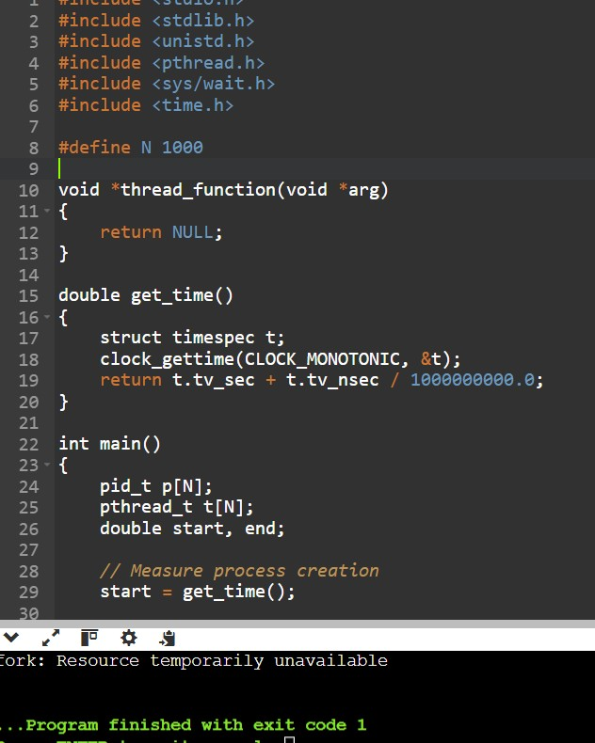

Results table
Run the program on your Linux system and enter the actual values:
Measurement | Time
Creating 1,000  processes | ______ seconds
Creating 1,000 threads | ______ seconds
The exact time depends on the CPU, RAM, Linux version, and system load. Do not use made-up values as measured results.

5. Alternative concept and complexity analysis
If threads are created instead of processes, the expected result is:
Feature | 1,000 processes | 1,000 threads
Creation time | Generally higher | Generally lower
Memory usage | Higher | Lower
Address space | Separate for each  process | Shared within the process
Code and data | Separate address spaces | Shared
Stack | Separate | Separate stack for each thread
Communication | Requires IPC | Easier through shared memory
Fault isolation | Better | A failure can affect the whole process
Why are threads generally faster?
- Processes need separate address spaces and process-management information.
- Threads share the same code, data, and resources of their parent process.
- Each thread still needs its own stack and thread-management information.
- Therefore, thread creation generally requires less memory and less overhead. 6. Comparison with earlier judgements
Earlier judgement | Measurement-based evaluation
Larger buffer improves  file-copy performance | Fewer read() calls are expected with a 4096-byte buffer than with a 1-byte buffer.
System calls have overhead | strace -c shows the number of system calls, and time shows the time spent in kernel mode.
Threads are generally faster to create | The measured thread creation time is generally expected to be lower than process creation time.
Processes use more memory | Each process has a separate address space, whereas threads share their process's memory.

7. Conclusion
The measurements help evaluate Linux performance. Larger buffers reduce system calls and improve file-copy efficiency. Threads generally require less creation time and memory than processes because they share resources. Actual results may vary depending on the computer and system load.
Important for your evidence: Run the programs on Linux, take screenshots of the strace -c, time, and ./measure outputs, and enter the actual measured values in your tables. Run the benchmark more than once and compare the results, because execution time can vary.

TASK 11 – Recommend and Defend the Operating-System Plan 4 Marks
Bloom’s Level: K5 – Evaluate Recommend the complete operating-system plan for the hospital.

Discuss:
- The type and structure of operating system for each environment
- The services, protection and I/O methods each will use
- The limitations and risks of your plan
- Whether the plan remains suitable for the group of three hospitals

Your recommendation must be based on evidence from your own analysis and measurements.

Alternative Concept and Complexity Analysis
If the whole system were moved to virtual machines on two large servers, instead of separate physical machines for each environment, what would the solution be? Evaluate the effect on response time for the monitors, the memory and processor overhead of virtualisation, and the effect on reliability.

Evidence Expected
A technically justified plan supported by analysis and measurements

Introduction
The hospital requires a reliable, secure, and fast operating-system plan to manage patient monitors, nurses' tablets, doctors' computers, databases, MRI systems, and communication between three hospitals. A combination of different operating systems is recommended instead of using one operating system for everything.

2. Recommended operating-system plan
Hospital environment | Recommended OS type and structure | Reason
Patient monitors | Hard RTOS – Microkernel | Provides predictable response and fault isolation.
Nurses' tablets | Mobile OS – Layered | Supports touchscreen, battery management, and communication.
Doctors' desktops | Desktop OS – Hybrid | Supports multitasking, medical applications, and user interfaces.
Central database | Server OS – Modular | Provides high performance, security, and service management.
MRI imaging  system | Multiprocessor OS –  Modular | Supports parallel processing of large medical images.
Three-hospital network | Distributed OS services | Supports secure data sharing between hospitals.

3. Services, protection, and I/O methods
Environment | Important services and protection | Recommended I/O method
Patient monitors | Real-time execution, error detection, process isolation | Interrupt-driven I/O
Nurses' tablets | User interface, communication,  authentication | Interrupt-driven I/O
Doctors' desktops | File management, program execution, access control | Interrupt-driven I/O
Database server | File management, encryption, access control, backup | DMA and caching
MRI system | Parallel processing, memory  management, error detection | DMA
Hospital network | Communication, authentication,  encryption, audit logs | Network interrupts where supported | and DMA
Protection methods:
- User authentication and role-based access.
- Encryption of patient information.
- Memory and process isolation.
- Regular backups and audit logs.
- Firewall and secure network communication.

4. Limitations and risks
- Different operating systems increase maintenance and training costs.
- Network failure may interrupt communication between hospitals.
- Cyberattacks may expose confidential patient records.
- Hardware failure may affect medical services.
- Software updates must be tested carefully to avoid interrupting hospital operations.
These risks can be reduced through regular backups, security updates, monitoring, and backup servers.

5. Suitability for three hospitals
Recommended
The plan is suitable for all three hospitals because each hospital can use local patient-monitoring and clinical systems while sharing important records through secure central or replicated servers.
If one hospital loses its network connection, its local systems should continue essential operations. Data can be synchronized when the connection is restored. Therefore, the plan supports scalability, reliability, and secure data sharing.

6. Alternative concept: Virtual machines on two large servers
Instead of separate physical machines, all environments could run as virtual machines (VMs) on two powerful servers.
Factor | Separate physical systems | Two-server virtualisation
Response time | More predictable for dedicated monitors | May increase due to virtualization overhead
Memory | Separate hardware memory | Shared RAM among VMs
Processor | Dedicated CPU resources possible | CPU resources are shared
Reliability | Failure may affect one environment | Server failure may affect many VMs
Maintenance | More physical systems to maintain | Easier centralized management
Cost | Higher hardware cost | Better hardware utilization
Evaluation:
- Virtualisation adds CPU and memory overhead because the hypervisor manages virtual machines.
- Multiple VMs sharing processors may cause delays.
- Patient monitors need predictable response times, so running them on shared virtual machines may create safety risks.
- Two servers provide some redundancy, but both must be configured for failover and data replication.
- If one server fails, the other must have enough resources to handle critical workloads.
My recommendation: Use virtualisation for databases, desktops, and general hospital applications. Keep critical bedside patient monitors on dedicated real-time systems rather than placing them on heavily shared servers.

7. Evidence from previous analysis and measurements
The earlier analysis supports this plan:
- Task 6 showed that larger file-copy buffers reduce system calls.
- Task 8 showed why interrupt protection and kernel control are important for timely monitor responses.
- Task 9 showed that DMA is suitable for transferring large MRI images.
- Task 10 compares system-call counts, CPU time, and process/thread creation time. These measurements can support efficient resource allocation.
Use your actual Linux measurements from Task 10 when presenting the evidence. Do not claim specific performance improvements unless your results demonstrate them.

8. Conclusion
A combination of RTOS, mobile OS, desktop OS, server OS, and distributed services is the best plan for the three hospitals. It provides reliability, security, fast response, and scalability. Virtualisation is useful for general applications, but critical patient monitors should remain on dedicated real-time systems to maintain predictable response times.

DAY-4 DESIGN CHALLENGE

TASK 12 – Re-evaluate and Adapt the Design 8 Marks

Bloom’s Level: K5 – Evaluate Changed Requirement
The hospital adds remote monitoring devices in patients’ homes that send readings over the internet, and moves patient records to a cloud service shared with the partner hospitals.

Re-evaluate your original design. You may RETAIN → MODIFY → or REDESIGN your original solution.

A. Impact Analysis – 2 Marks Identify which operating-system types, services and protection mechanisms are affected.

Evidence Expected A clear analysis of how the changed requirements affect the original design.

B. Evaluation of the Original Design – 2 Marks
Evaluate whether your plan can support home devices and cloud records, considering response time, reliability and security.

Evidence Expected A technically supported evaluation of the original design.

C. Adaptation or Redesign – 2 Marks
Describe the revised plan (for example: an embedded real-time OS on home devices, a distributed system for shared records).

Evidence Expected An appropriate design response.

D. Evidence-Based Defence – 2 Marks Defend your decision using evidence and the trade-offs involved.

Evidence Expected
A well-supported final decision integrating evidence and the changed requirements.

Introduction
The hospital has introduced two new requirements:
- Remote monitoring devices in patients' homes send health readings through the internet.
- Patient records are moved to a cloud service shared by three partner hospitals.
The original operating-system plan is useful, but it needs some modifications to support remote devices, cloud storage, reliability, and stronger security.

A. Impact Analysis (2 Marks)
The new requirements affect the following operating-system types, services, and protection mechanisms.
Area | Impact of the new requirement
Operating-system type | Home devices need an embedded RTOS. Cloud servers need a server OS.
OS structure | Microkernel or small modular RTOS is suitable for home monitoring devices.
Communication | Internet communication is required to send readings to the cloud.
File management | Patient records must be stored and retrieved from cloud storage.
Security | Strong authentication, encryption, and access control are required.
Reliability | Backup systems and continuous monitoring are needed to prevent data loss.
I/O management | Sensors use interrupt-driven I/O to collect readings efficiently.
Impact explanation:
- Home monitoring devices must collect readings and respond quickly.
- Internet communication introduces network delay and connection failures.
- Cloud storage allows all three hospitals to access shared patient records.
- Patient information needs stronger protection because it travels through public networks.

B. Evaluation of the Original Design (2 Marks)
The original design can support the new requirements with some changes.
Requirement | Original design evaluation
Response time | RTOS supports fast local monitoring, but internet delay affects remote data delivery.
Reliability | Local systems are reliable, but network and cloud failures may interrupt access.
Security | Existing authentication and encryption are useful, but stronger internet security is required.
Data sharing | Distributed services can support communication between three hospitals.
Scalability | Cloud services can support increasing numbers of patients and devices.
Evaluation:
The original design is suitable for hospital-based systems, but it is not fully sufficient for home monitoring and cloud-based records. Internet delays cannot be completely controlled by the hospital. Therefore, home devices must continue basic monitoring even when the internet connection is unavailable.

C. Adaptation or Redesign (2 Marks)
I recommend MODIFYING the original design instead of completely replacing it.

Revised operating-system plan
Environment | Revised OS type and structure | Main purpose
Hospital patient monitors | Hard RTOS – Microkernel | Fast and predictable local monitoring
Home monitoring devices | Embedded RTOS – Small modular or microkernel | Collect readings and detect important events
Nurses' tablets | Mobile OS – Layered | View patient readings remotely
Doctors' desktops | Desktop OS – Hybrid | Access patient information and applications
Cloud patient records | Server OS – Modular | Store and manage shared records
MRI systems | Multiprocessor OS – Modular | Process large medical images
Three-hospital network | Distributed system | Share records securely between hospitals

Revised architecture diagram
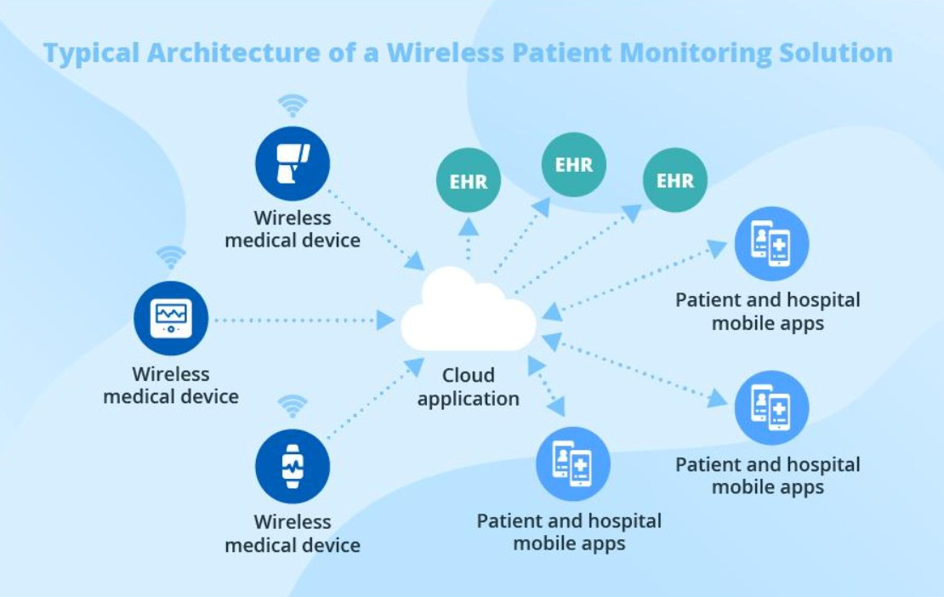

Working process
- Sensors in the patient's home collect health readings.
- The embedded RTOS processes the readings locally.
- The device sends readings securely through the internet.
- The cloud service receives and stores the readings.
- The three hospitals access authorized patient records.
- Doctors and nurses view the readings using their computers or tablets.
- If the internet is unavailable, the home device temporarily stores readings and sends them after reconnection.

Additional protection mechanisms
- Encryption: Protects readings during internet transmission and cloud storage.
- Authentication: Confirms the identity of users and devices.
- Role-based access: Allows only authorized doctors and nurses to access patient records.
- Backup: Prevents permanent data loss.
- Audit logs: Record who accessed or changed patient information.
- Local alerts: Allow home devices to provide important alerts without depending entirely on the internet.

D. Evidence-Based Defence (2 Marks)
The modified design is the best choice because it combines local real-time processing with cloud-based data sharing.
Evidence from earlier tasks | Support for the revised design
Task 2 – RTOS evaluation | Supports predictable response for patient monitoring devices.
Task 3 – Microkernel evaluation | Provides better fault isolation for critical monitoring systems.
Task 8 – Interrupt and protection analysis | Supports efficient sensor handling and protection of critical operations.
Task 9 – DMA and memory hierarchy | Supports efficient transfer of large MRI images.
Task 10 – Linux measurements | Buffer-size and system-call measurements help improve data-transfer efficiency.
Trade-offs:
- Cloud storage improves sharing and scalability but depends on internet availability.
- Encryption improves security but adds some processing overhead.
- Local storage improves availability during network failures but requires synchronization later.
- Embedded RTOS improves local response time but has fewer features than a general-purpose OS.
The exact performance should be confirmed through testing with real devices, network delays, and cloud-service availability.

Conclusion
I recommend modifying the original operating-system design by adding embedded RTOS-based home monitoring devices and a secure cloud-based distributed system. Local monitoring will continue even during internet failures, while cloud storage allows three hospitals to share patient records. This design provides better scalability, reliability, response time, and security for the hospital's new requirements.

MARK DISTRIBUTION
Task | Bloom’s Level | Marks
Task 1 – Requirements of Each Environment | K5 – Evaluate | 4
Task 2 – Types of Operating Systems | K5 – Evaluate | 3
Task 3 – Operating-System Structures | K5 – Evaluate | 4
Task 4 – Operating-System Services | K5 – Evaluate | 4
Task 5 – System Calls | K5 – Evaluate | 4
Task 6 – Cost of System Calls | K5 – Evaluate | 4
Task 7 – Process Control System Calls | K5 – Evaluate | 4
Task 8 – CPU States and Protection | K5 – Evaluate | 3

Task | Bloom’s Level | Marks
Task 9 – Memory Hierarchy and I/O | K5 – Evaluate | 4
Task 10 – Measurement and Comparison | K5 – Evaluate | 4
Task 11 – Final Recommendation | K5 – Evaluate | 4
Subtotal |  | 42
Task 12 – Day-4 Design Challenge | K5 – Evaluate | 8
TOTAL |  | 50

Submission Requirements
- GitHub repository link (mandatory) containing the executed code for every task, including every completed “Complete the Code” program, script and configuration file, with input files, output screenshots and a README.md.
- Your assignment report containing the required evidence for Tasks 1–12, including requirement tables, diagrams, strace and time outputs, measurements and complexity analyses.

Assessment Verification
Students may be asked to explain, execute or modify any part of their code during a brief verification discussion/viva. The student should be able to explain and defend the work submitted as their own.

